

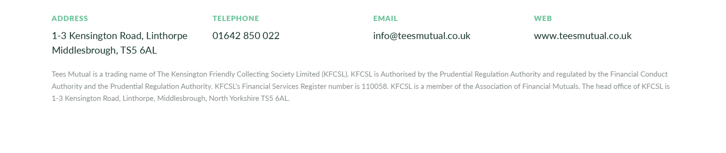

**Kensington Friendly Collecting Society Limited t/a Tees Mutual**

**Registered Office: 1/3, Kensington Road, Middlesbrough**

The 119th Annual General Meeting of the above-named Society will be held on Wednesday 20 November 2024

at The Holy Name of Mary Parish Hall, The Avenue, Linthorpe, Middlesbrough, TS5 6QT commencing at 7pm.

**AGENDA**

## GENERAL BUSINESS

1. Chairman’s opening remarks.
2. To consider and approve the Minutes of 118th AGM.
3. Chairman’s Report.
4. Chief Executive’s Report and Business overview.

**SPECIAL RESOLUTION**

1. Approval of the transfer of the Society’s engagements to the Independent Order of Odd Fellows Manchester Unity Friendly Society Limited on the terms summarised in the circular to members dated 18 October 2024.

**ORDINARY RESOLUTIONS**

1. Approval of the following partial alteration to the Society’s rules:
   1. Renumber Rule 5 as paragraph (1) of Rule 5;
   2. Add the words “Subject to paragraph (2) of this Rule 5” at the beginning of paragraph (1) of Rule 5; and
   3. Insert the following paragraph as paragraph (2) of Rule 5:

“With effect from the date on which an Instrument of Transfer of the Society’s

engagements to the Independent Order of Odd Fellows Manchester

Unity Friendly Society Limited is delivered to the Financial Conduct Authority for registration, those members who would have been eligible to share in the apportionment of any surplus under paragraph (1) of this Rule 5 shall cease to be eligible for any further such apportionment (without prejudice to any bonuses previously declared and allocated to their policies or to any final bonus that would otherwise have become payable on or before the effective date of the transfer) but instead shall be entitled with effect from the effective date of the transfer to the guarantees and fixed bonuses set out in the Instrument of Transfer.”

* 1. Delete Rule 37(5).”

1. Acceptance of 2023 Accounts, Committee of Management Report, Auditors Report and annual bonus decision.



1. Approval of Remuneration Report and COM remuneration.
2. Re-appointment of Anderson Barrowcliff Limited as auditors.
3. Re-election of the Board of Management.

* Re-election of Mark Brooks
* Re-election of Debra Barker
* Re-election of Gillian Dobson
* Re-election of Andrew Douthwaite
* Re-election of Philip Carey
* Re-election of Brian Douglass
* Re-election of Dominic Gardner
* Re-election of Mark Dobing
* Re-election of Liam Moloney
* Re-election of Georgia Armin

1. Any Other Business.

By Order of the Committee of Management Mark Brooks **Chair**

Brian Douglass **Secretary**

Copies of the 2023 annual report and accounts detailing the biographies of the directors seeking re-election and Remuneration report can be found on the Society website ([www.teesmutual.co.uk](http://www.teesmutual.co.uk/)) or by contacting the Office on [info@teesmutual.co.uk](mailto:info@teesmutual.co.uk) or

01642 855199.

Any member of the Society entitled to attend and vote at the meeting may appoint a proxy to attend the meeting and, on a poll, to vote in his or her place. The proxy need not be a member of the Society and the member may direct the proxy how to vote at the meeting. A form for appointing proxies is enclosed with this document and must be returned to the Secretary at 1-3 Kensington Road, Middlesborough TS5 6AL no later than 48 hours before the meeting. Spare forms are also available from the Secretary at the same address.